RUNNING CAMELS BASEBALL CAMPS, LLC.
Athletic Camp Medical Information Waiver

Camp Type (Circle One): YOUTH PROSPECT TEAM

Camp Dates:____________________________________________________________________

Participant Name:________________________ Date of Birth:____________________________

Parent/Guardian Name:__________________________ Parent/Guardian Phone:____________

Emergency Contact Name:_________________________________________________________

Relationship to Participant:____________________ Phone Number:_______________________

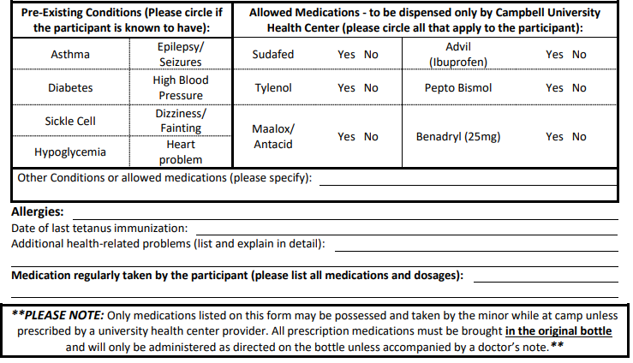
By signing this document, I certify that within the past year the aforementioned participant has had a physical examination by a physician, or other licensed medical provider, and that he/she is physically able to participate in the sports camp/clinic activities. Additionally, by signing this document, in the event of an injury, illness, and/or accident involving my son/daughter, I hereby give my consent for medical treatment(s) at Campbell University Health Center. I hereby give my consent to: a certified athletic trainer and/or his/her designee to render and supervise on-site first aid treatments, to the appropriate camp/clinic personnel to properly transport my son/daughter to an appropriate medical facility for care, and to a licensed physician to hospitalize and secure proper treatment(s) for my son or daughter, including injections, diagnostic procedures, anesthesia, surgery, and/or other reasonable and necessary procedures. I hereby authorize my health insurance company to pay for benefits and for the cost of such treatment(s). I also authorize the disclosure of medical information to my insurance company for the purpose of any claim

Parent/Guardian Signature___________________________________ Date: ______________________________

Insurance Policy Holder_______________________DOB:_____________ Last 4 of SS________

Company:___________________________ Policy No:________________Group No:_________

